What if there were only portraits or photos of Australian birds left as a reminder of what once lived in the Australian bush?

Engage | Introduce Inquiry: This is my question:  What is happening to the redtailed black cockatoo? ‘Should I be worried about them? Are they endangered?’  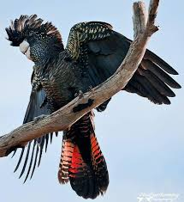 | Take a walk or a cycle in the park…… or find a bush track near your home.  Look, listen and notice what are you seeing/ hearing/ smelling. Ask yourself some questions….lots of them  When you get home check online. Google in the key words you want to explore… find images/ texts/video clips to help you connect with question that you have  What are you noticing?  What interests you about the information that you are collecting and the birds that you see? Did you see any information about black cockatoos?  K What do you know now about Birds in the Australian bush?  Mind map all that you can think of….. everything about birds!!  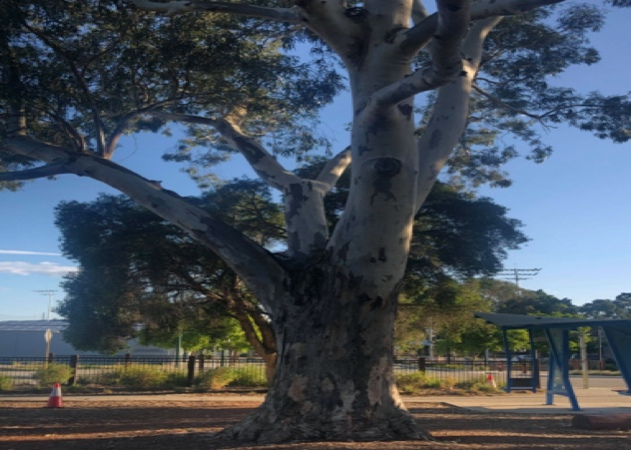  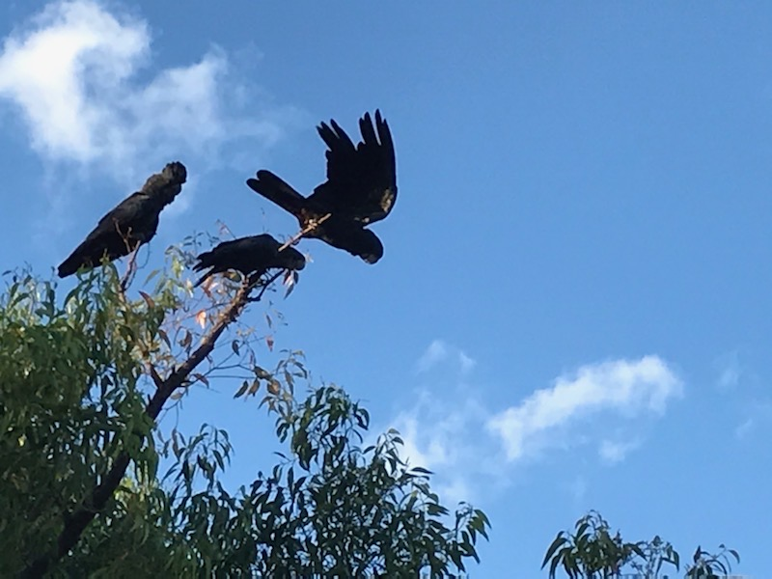  What are you really curious about?  Sort out all the information that you have in your mind map into some sort of idea piles…  - Birds/type  - Variety of bird and it’s characteristics.  - Habitat  - Food  - Climate  - Water  and anything else that you have noticed about the birds that you saw on the track or in the park  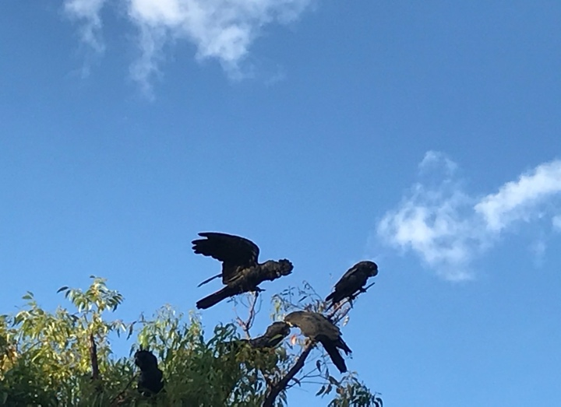  Think really hard about this…  Think again about what you are curious about.  What might your inquiry question be?  What’s happening?  Where have?  I wonder what?  GRAPPLE with the hard stuff here!  Try some original thinking NOT regurgitation of facts  Think hard about how you might take a little risk with your new learning  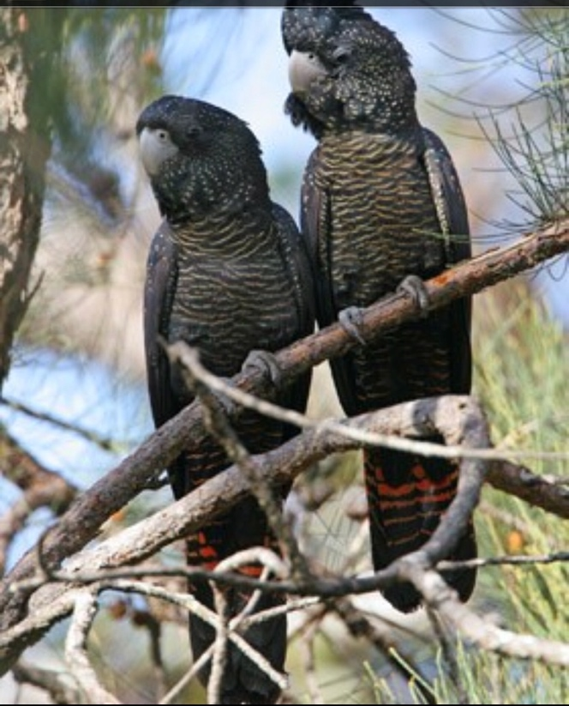  How will you present your new learning?  What could you do?  Think about how….perhaps:  - A 3 minute video clip  - A photo montage or  - A story or a play  - A prezi or a powerpoint  - A diorama using a photobox  - A collage or a mural  - Or…. Your idea?  When you explore your inquiry create a rubric and tick off all the tasks as you create them to answer the inquiry.  For example:  - Create a bird that you have seen in the bush or the park  - Create a bird habitat for the bird: Trees/ bush/ seeds/ leaves etc.,  - Know all the parts of a bird and its features…… and use the ‘language’ related to birds...  - Life cycle?  - Flight?  - Feathers?  - Nests?  - Food? Food webs/insects /bugs etc.,  - Endangered or not?  - More?
Explore | Clarify and review Inquiry question.  Research online or read.  Check out The Birdlife Australia: Aussie backyard Bird count.  See what they are telling you about the bird you are interested in. Is it endangered?  Check out some videos about what local birds or animals might live near the park or track. There are some excellent websites from the local state and Australian Government and local councils…  https://www.dpaw.wa.gov.au/plants-and-animals/plants  https://www.australiangeographic.com.au/category/topics/wildlife/  https://www.wa.gov.au  https://www.dpaw.wa.gov.au  https://www.australia.gov.au/about-australia/our-country/our-natural-environment  Make sure that you read and look at what the aboriginal people of this country are telling you about the bird that you are concerned about.  Do you know someone who might know about this topic?  Can you interview them?  Is there a Bird sanctuary or a bushland setting nearby?  Look at articles/ websites about Australian birds that are endangered. | What Hands on activities can you do to explore your ideas more?  e.g. How does a bird fly?  What is happening when they fly?  Go outside and watch?  Try flight activities with paper?  How big are birds?  What is the size range?  Why? Are the bigger bird endangered?  Features? Life cycles? Nests? Habits? Food?  Exploring/ testing ideas  Making feathers / nests.  Comparing/contrast  Observation opportunities collecting data about birds  Now make a poster of the inquiry question after you done some things and explored some ideas. Is this what you are still interested in?  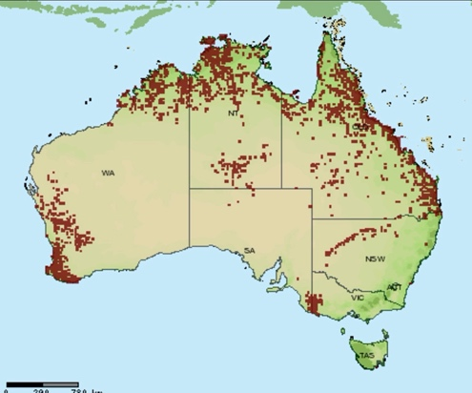  Are red tailed black cockatoos really endangered?  Do you agree or disagree with the information that you are collecting? What is your view?  Do you need to adjust your inquiry question?  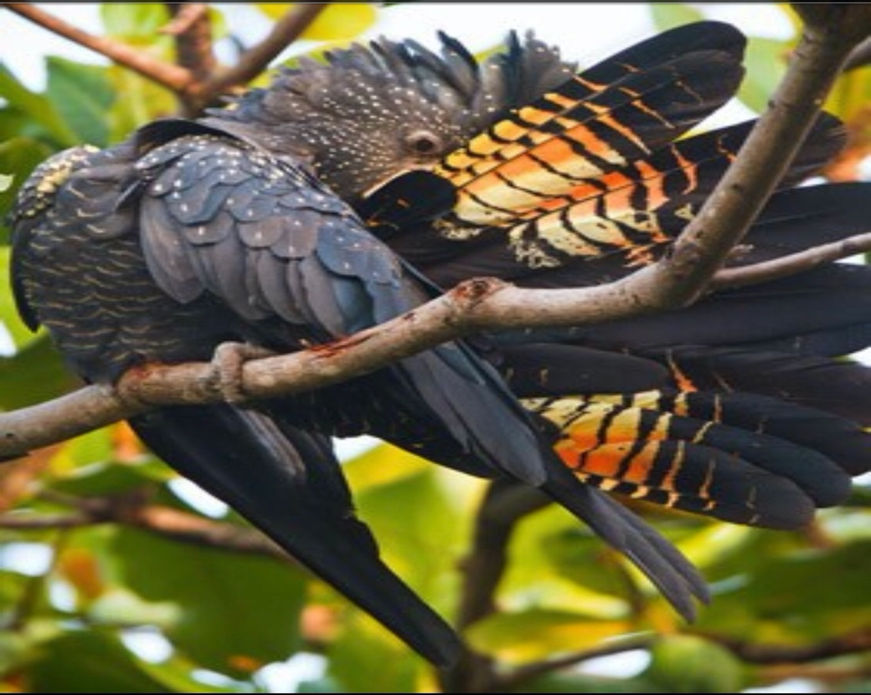
Explain | Key words  Exploring presentation mode…. how could Music/ Dance/ Drama/ Art/craft task/Narrative illuminate the inquiry…. How could the science be represented in this way? | How are you going to present all the new information that you have gained?  Start looking at your ideas for a final product or presentation.  Start putting everything that you have collected into a folder or a scrap book….. sort all of your information into piles.  Now: What will you create?  - A 3 minute video clip  - A photo montage or  - A story or a play  - A prezi or a powerpoint  - A diorama using a photobox  - A collage or a mural  - Or…. Your idea?  What is your presentation option?
Elaborate | Reconstructing viewpoint  Consequence wheel  Investigate new thoughts, information and concepts | Now begin to collate in all of the work that you have created and your ideas into your final presentation:  Look at your ideas and work that you have collected as you tried to find the answer to your inquiry?  What are the new concepts that you want to share?  What do you know now?  Can you answer your inquiry question?  What is the story that you want to share?
Evaluate | Compiling your final product or presentation  Reflecting upon new information that they have provided.  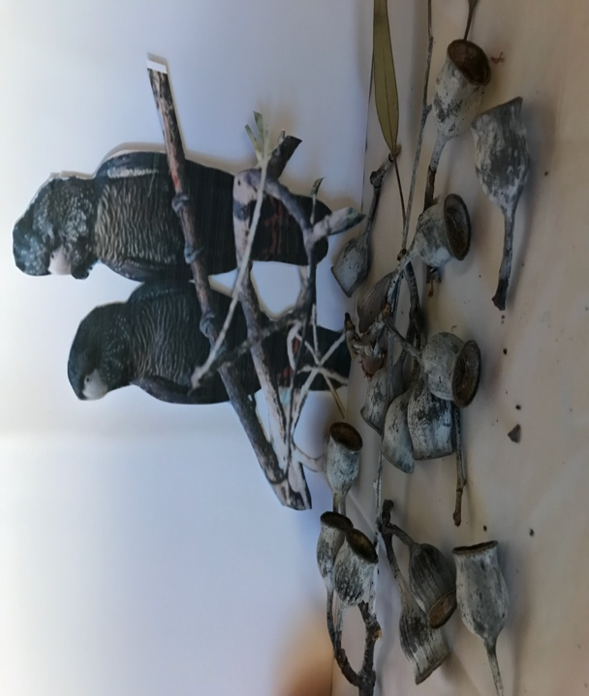  Make sure that you have the evidence to substantiate your opinion. | Think about the depth of the assessment at the end of this inquiry.  How have you demonstrated your new knowledge?  Have you answered your inquiry question?  Check out the rubric that you created at the beginning.  Have you achieved what you set out to do?  Can you skype or talk to someone to present your work to them?  Show them what you have created and talk them through it  Get them to give you some warm cool [but not cruel] and hard feedback.

