What ‘s the suitcase story?
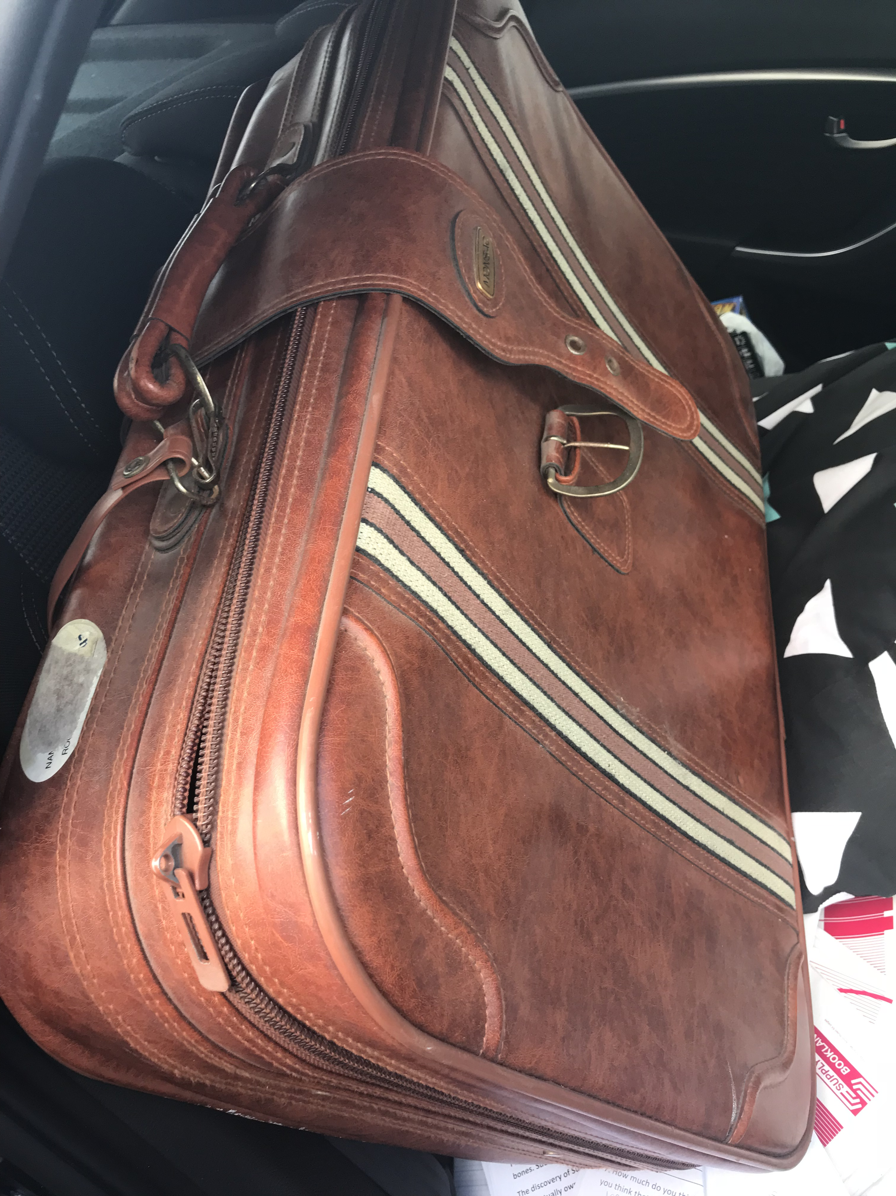

This project fits within the Citizenship curriculum in years 5,6.
It is designed to Stimulate curiosity about the student’s family connections . How are their people connected to another country? Where have they come from? How stong is their connection to the country ?
It would be wise to use a WWWW H and W framework to support the student’s exploration of these cultural connections.

Have some maps/ posters/ images or objects alongside an old case before you.
Sit the students in a circle. Be a naïve inquirer.

Ask the inquiry question:
What is the suitcase story?

Bring in an old suitcase from the Op shop and place it in the centre of the classroom.

Pose some questions:
I wonder:

Who owned this suitcase? Is it new or old?
Where did it start its journey?
When?
Who bought it?
How much did it cost them?
What was packed inside it?
How excited were they to pack the case?
Did they want to come here?
Where did the suitcase go on its way here?
Have a look at a map of the world.
What country did it come from?
Can you think of why the person who owned the suitcase wanted to travel to Australia to begin a new life?
Can you think about mapping it’s journey to your possession? That will take some thinking and planning….

Find out what the students know…. ..everything that they can come up with about where this old suitcase could have been.
Mind map ideas connected to the question you have posed with the students on a whiteboard/ smartboard… everything you and they can think of…. everything related to the question “ What is the suitcase story?”.
As much as you can.

Sort Mind map ideas with the students into 4/5 key areas using a structured overview or similar framework, so that you have connected ideas grouped together: e.g. WWWWH and WHY maybe
Migrant
Age
Country
Travelled here? How? Boat? Plane? Overland?
The journey….
When?
What was it like when they got here?

Start looking at the curriculum areas for Year 5/6 and group the subject areas into tasks from specific curriculum areas.
Identify and highlight 2/3 key curriculum goals from each subject area: Maths, Science, English, T and E, Geography, History, Art/ Design, etc.,
e.g.
Geography: A map of the suitacse journey from purchase to destination.
Art / design: Travel ticket: Calligraphy- destination / cost/ Name/ Address
Maths graph: data to show how many people accompanied the suitcase owner: Children / men/ women/ babies
English Narrative: The tale of the suit case owner
Read and recall ‘The arrival ‘ by Shaun Tan. Use the images of the text on the OH whiteboard to stimulate daily discussion.
Read Ahn Do’ s story and any other texts about migration past and present .

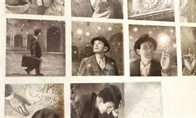

Create a task sheet for the duration of the inquiry :
Get the students to complete tasks as they explore this inquiry and add to their suitcase towards a final exhibition at the end of term where they answer the Inquiry question:

What is the suitcase story?

