**Civics and Citizenship: Year 3**

**In the Australian Curriculum:** Humanities and Social Sciences

Citizenship: A legal status granted by birth or naturalisation to *citizens* involving certain *rights* (for example, protection, passport, voting) *and responsibilities* (for example, obey the *law*, vote, defend country). A modern sense incorporates three components: civil (*rights and responsibilities*), political (participation and representation), and social (social virtues and community involvement). An identifiable body of knowledge, understanding and skills relating to the organisation and working of society, including a country's political and social heritage, democratic processes, government, public administration and judicial systems.

Civics: An identifiable body of knowledge, skills and understandings relating to the organisation and working of society. It refers to a nation’s political and social heritage, democratic processes, government, public administration and legal system.

By the end of Year 3, students explain the role of rules in their community and the importance of making decisions democratically.

* They describe how people participate in their community as active citizens.
* Students pose simple questions about the society in which they live.
* They collect information from sources to answer these questions.
* They examine information to identify a point of view and draw simple conclusions.
* Students share their views on an issue and describe how they participate in a group. They present their ideas and conclusions in oral, visual and written forms using civics and citizenship terms.

**Questioning:**

Pose questions to investigate people, events, places and issues (ACHASSI052)

**Researching**

Locate and collect information and data from different sources, including observations (ACHASSI053)

**Evaluating and reflecting**

Interact with others with respect to share points of view (ACHASSI059)

Reflect on learning to propose actions in response to an issue or challenge and consider possible effects of proposed actions (ACHASSI060)

**Civics and citizenship:**

Why people participate within communities and how students can actively participate and contribute (ACHASSK072)

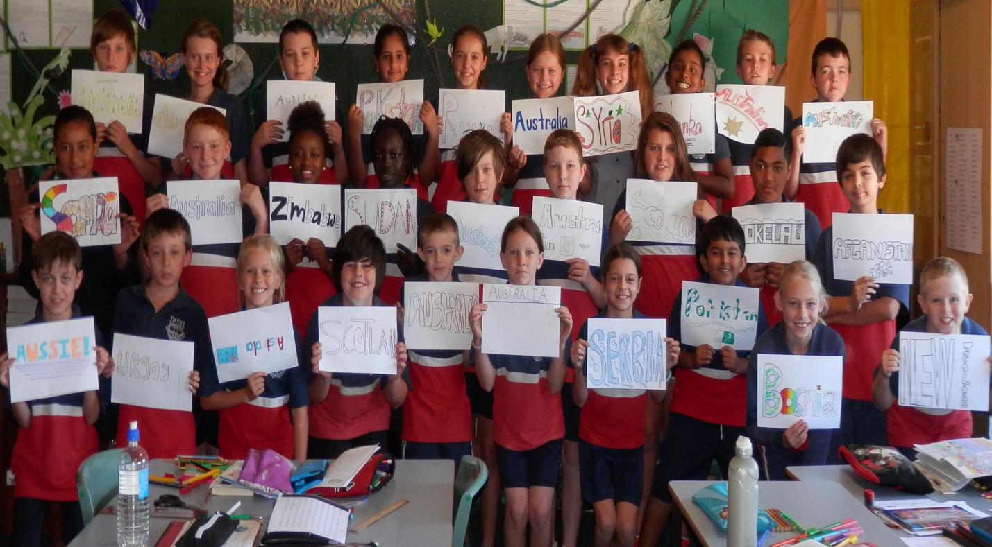

**Tuning in:** ‘I’m Australian too’ by Mem fox: Text and Read aloud: YouTube clip

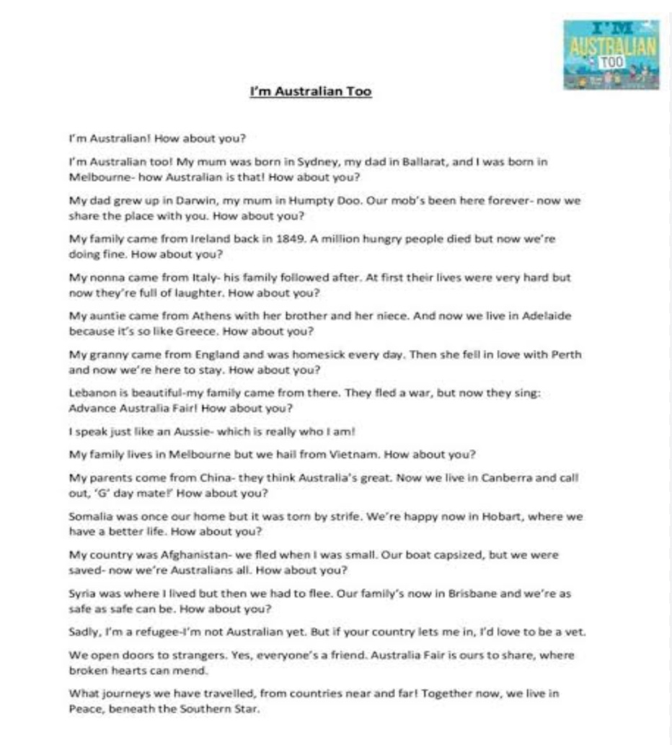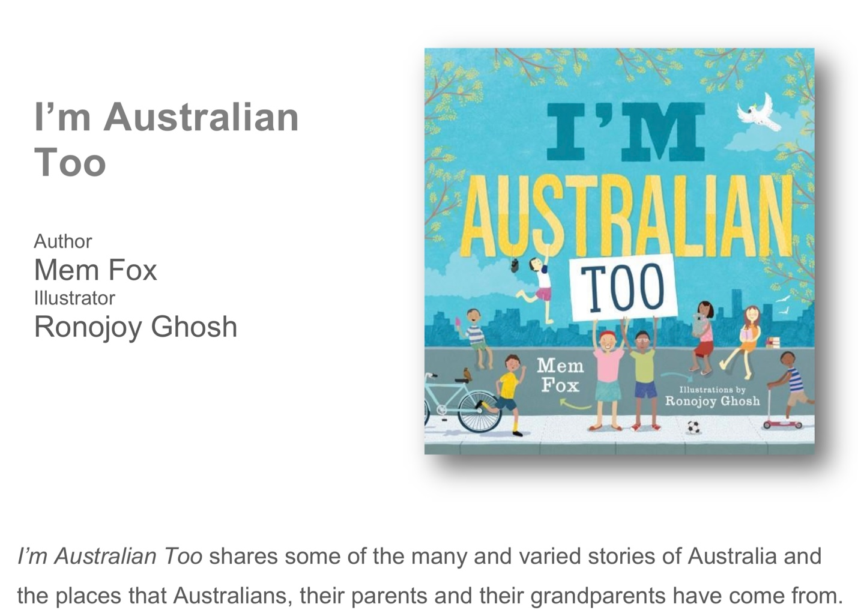

**Project Task:** Students create an 8 page folding booklet about themselves in community:

Titled **‘ Here I am. I am an Australian citizen.’**

**Finding out:**

**Inquiry question:**

**Class activity: Where did your parents, grandparents, families come from?**

Do you know?

How can you find out?

On a world map encourage the students to place a marker of the country and place that their family came to Australia from. Collect the information from the whole class.

Students create a Citizenship folding booklet on the wepublish app or with a large sheet of plain paper.

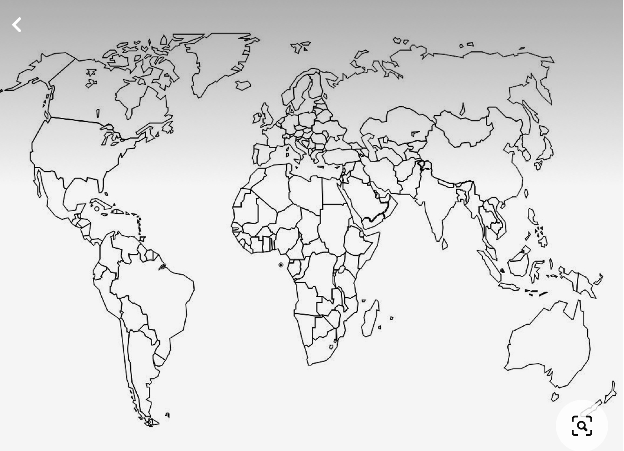

Refer to Action scholastic Teacher notes on I’m an Australian too.

**Reframe Inquiry question:**

**I am a citizen of Australia: What does that mean to me?**

Building upon Mem Fox’ book ‘I’m an Australian too.’

**Sorting out:**

**Pose more questions for discussion:**

What is a citizen? What are you a citizen of? How do you know?

**Page 1 :**  **Here I am:** I am a citizen of Australia.

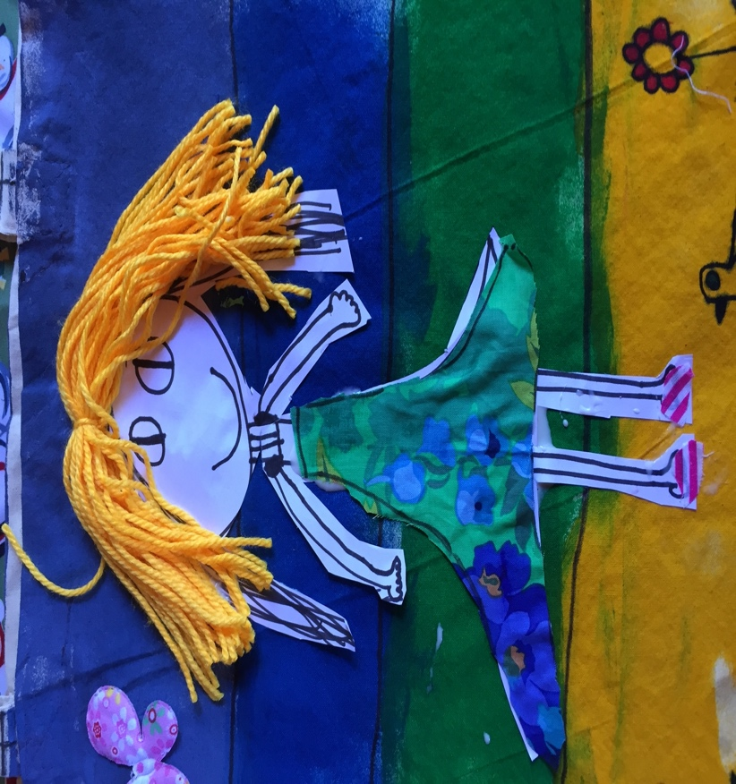Drawing of student: collage/ drawing/ painting

**Page 2.** **My family came from:** Encourage students at ask and answer some prompt questions about themselves

* I live
* I live with
* I live with my family in a house near..
* I go to school… etc.,
* I live in a community…etc.,

**Define community:** What is it? [SCSA defines communities as groups that make decisions in different ways and voting is a way that groups make decisions democratically (ACHCK001)

Who makes rules, why rules are important and the consequences of rules not being followed (ACHCK002)

 Why people participate in community groups, such as a school or community project, and how students can actively participate and contribute to their local community (ACHCK003) ]

**Sorting out:**

**Page 3:** **I belong to lots of communities**:

My family belong to… …communities.

e.g. I go to school, I go to church, I go to the shops, I belong to the Hockey club, I play cricket, I do gymnastics etc., I go to Book club, I .. etc.

When we are together in these communities we…. [Brainstorm or Mind map]

* Are all together
* Are part of a group
* Part of a team
* Share
* Take turns
* Wear a uniform
* Play together etc.,

**Page 4:** **These are my communities:**

Students create a circle diagram of all the communities that they participate in.

**Page 5: Table: What helps communities to work well?**

**K W L**

Prompt questions:

K. What do we know about communities?

W What do we want to know? Collect these questions on a Civics question space.

K. What are the structures that they all have? Tabulate on **Page 5**

* A leader
* Rules
* A uniform
* Processes and procedures
* Regular meetings
* Sharing and equity
* Some communities are big, some are small
* We are all the same but we are all different
* We are just together to do something we like to do....
* Communities protect us
* Communities have rules

**Going further:**

**Page 6**:

In the community that I belong to we:

Meet regularly

Structures

Place to meet that stays the same

People who are different

People who are the same

Kids

Adults

Men girls

Boys

Women

**Page 7:** This helps us to: share/ connect/ cooperate: Students create an image or a symbol / product that shows connectedness to their community.

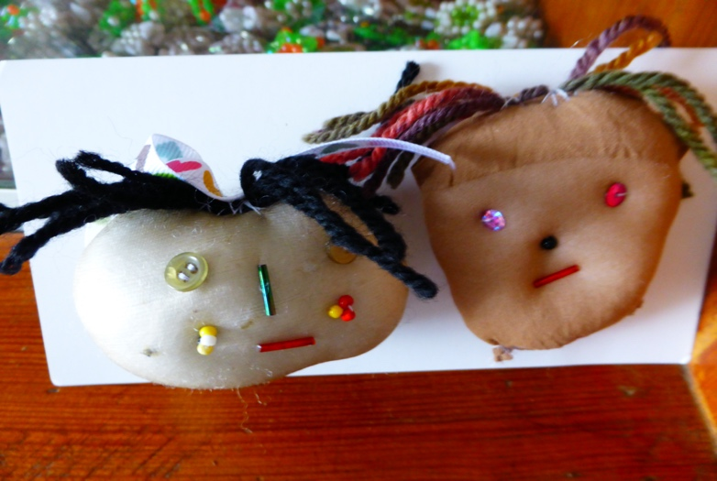

**Page 8.** **Exhibit or showcase new learning.**

**Answer to Inquiry question:**

**This is what it means to me to be a citizen of my community in Australia**

We are all different but we are all the same in our communities we are connected and we look after each other. We are safe. Students draw/ colour paint their own image in large jigsaw piece and then fit all the images together into a Group collage.

