The Brentwood door birds or the Brentwood doors with birds on them????:

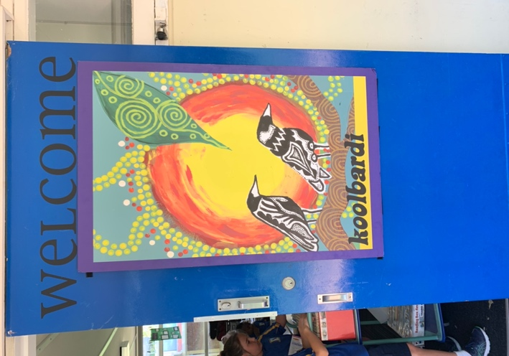
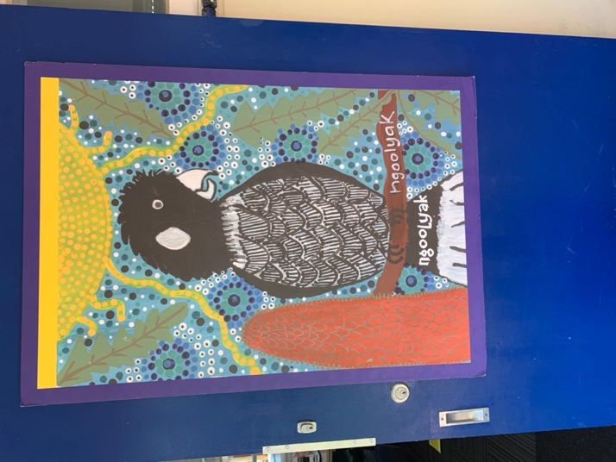
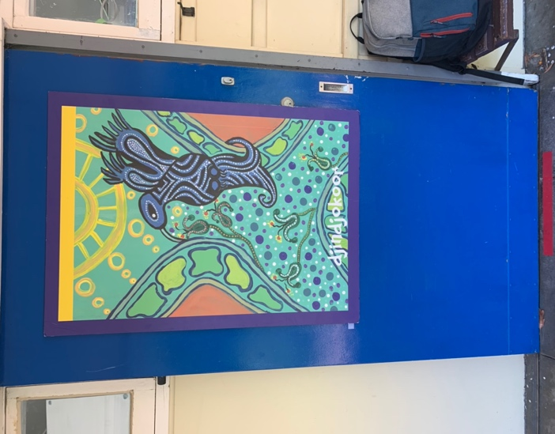

We have birds on our doors at Brentwood.
Our Principal painted them. A suggestion as part of the 2022 student orientation:
Each door in the school has a painting of a local bird and its traditional Noongar name.
Our intention is for the children in the school to be able to identify the image of the bird, the name of the bird in English and Noongar and the number of the room where the Bird painting hangs on the door.
- Tuning in:
We want the students to walk through the school and notice what bird is painted on what door. What are they noticing?
What is the Noongar pronunciation of each bird name?
Break this name up into syllables or morphographs and learn each of them. e.g kool/ bar/di means magpie in English.
What bird painting is on what Classroom door?
What is the number of the door?
What class is in there?
THEN: Students choose the bird painting that most appeals to them. They look at the painting and replicate it WITHOUT the bird in the painting onto a small card. It must be the same colours/ shapes and patterns as the Painting on the door.
The student then adds the room number to the card that they have created.
This will mean that there will be sets of number cards for each Bird on the door painting. These will be very useful for the front office ladies.
Students then play a game in class where they identify
- The bird in the painting
- It’s English name
- It’s Noongar name
- The room number of that bird door.
They can all go to the correct numbered door
THEN:
The inquiry question:
Finding out:
What is the significance of this door/ bird to his country here near Blue Gum lake?
What do we know about the Brentwood birds?
What do we want to know?? Off they fly….into the inquiry.
