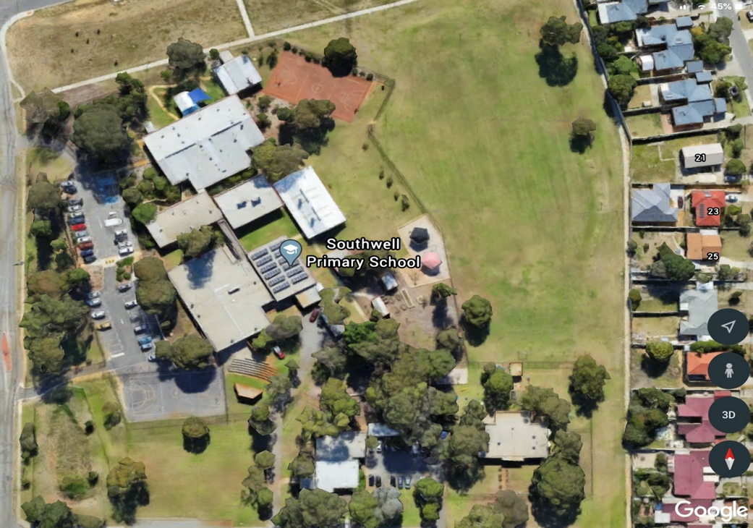
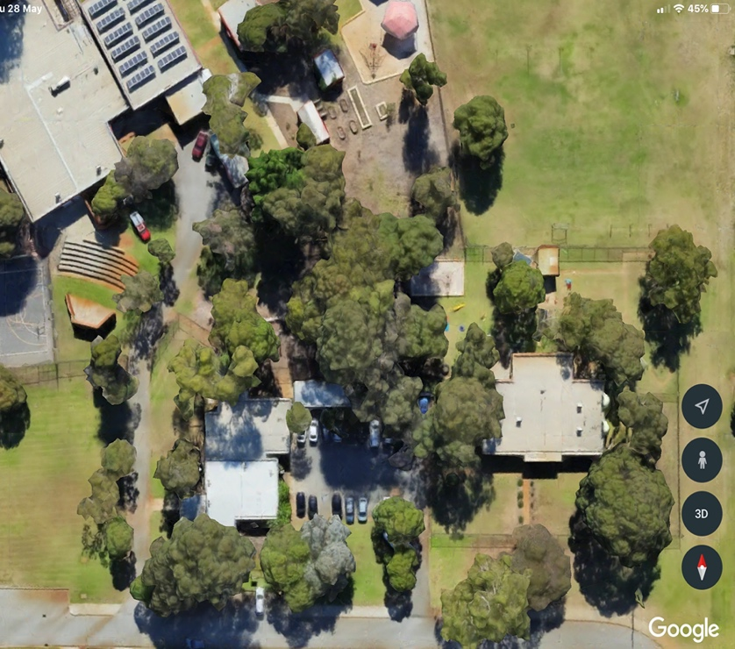
What do you know about our school land? What’s happening?

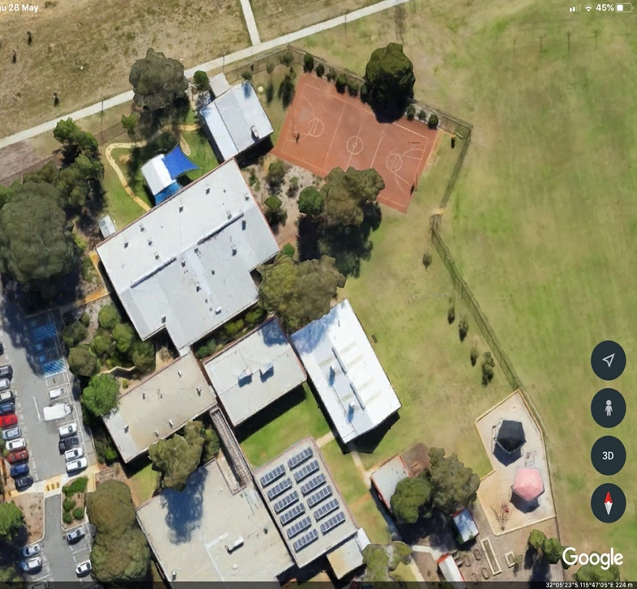

This is what the school looks like from above. There are patches of green that you can see from the satellite images.
What’s happening in those patches of green? What lives there in the marluk?
Let’s find out….
Before you explore the school grounds… there is only one rule.
Respect: Everyone has a right to be heard and considered. You are free to explore. Think about choosing a partner to do this exploring with.
This will give you an opportunity to hear what they think and they can hear your thoughts about what you discover too.
What does it look like/ Feel like/Sound like to co-operate?
Take a walk together through the school grounds. Any direction.
The fences are your boundary. Where will you and your partner start? You will be looking for plants, birds, seeds, leaves, insects, anything ‘natural’ that you think are interesting..
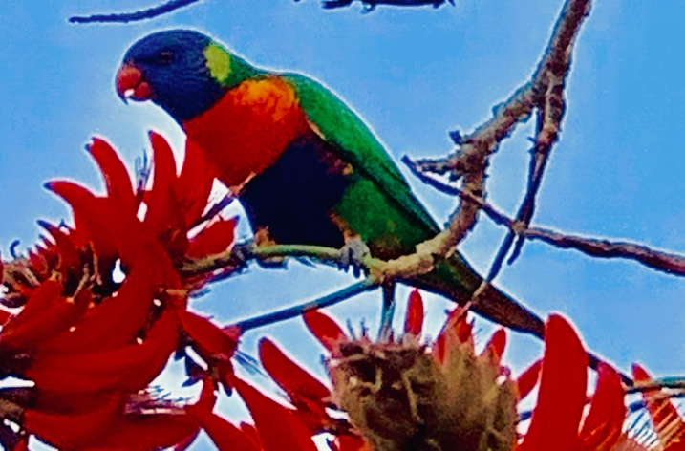

Make a list of 7/8 things that you notice as you walk through the school grounds and make sure you note where they were. Perhaps make a mud map of your discoveries.
When you get back together share your list of discoveries…. Discuss what you both saw and make a master list of 7/8 places in the schoolgrounds where you both think the other kids should stop and look, and think about
Now make a master list from all of the class discoveries all together and place the spots on a mud map. Talk together about where the best places to look at nature are and what you noticed. Perhaps make some little flags to show where and number the flags 1-12/16. That can become your walk track through the school.
Make the last place that you stop a Yarning circle down the hill under the trees.
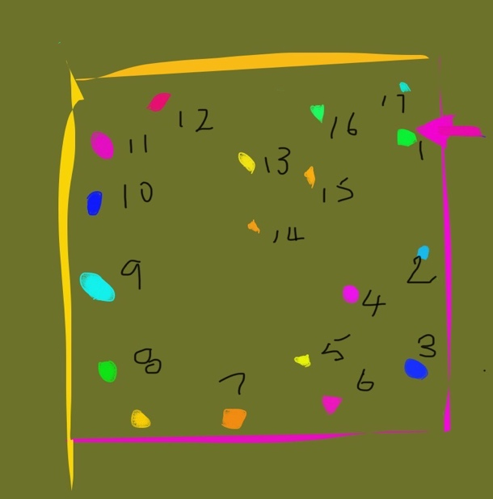
When you go to each flag on the track:
Sit for a while. Make sure you have a
pencil and paper

- Look
- Listen
- Touch
- Smell and feel.
What are you noticing?
What are you discovering?

Perhaps make a table to record your discoveries:
Could you draw what interests you at each flag as you go around the track?
What are you noticing? Maybe create a table for this information?

Flag 1 | 2 | 3 | 4 | 5
6 | 7 | 8 | 9 | 10

Could you collect some stuff in a dilly bag as you go around the track that you can share with your classmates later?
When you get back to class with your partner, talk to them about what you were very interested in… what were you curious about?
What did you collect?
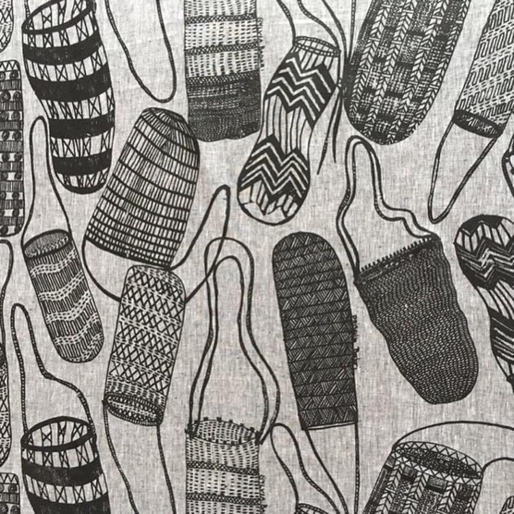
What did you notice?

Was it the marluk?
The jerrup?
The boorn
The boodja?

What really interested you at the flag
you stopped by??
What could your inquiry question be?
Could it be?
What’s hiding under the leaves?
What eats these berries?
What’s happening to the bees?
Are here bandicoots here?
Where do the magpies live?
What lives in that big tree?
What’s the sap from the redgum tree useful for?
When does the gum tree drop its gum nuts?

OR?

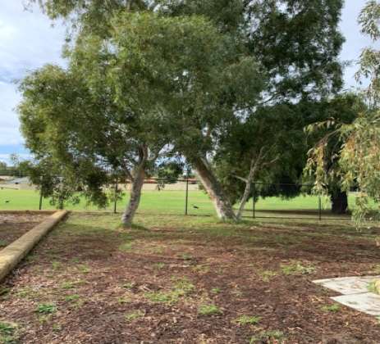
There are lots and lots of books in the library and information online that you could read that would help you to find the answers to your questions. Look and see what you discover.
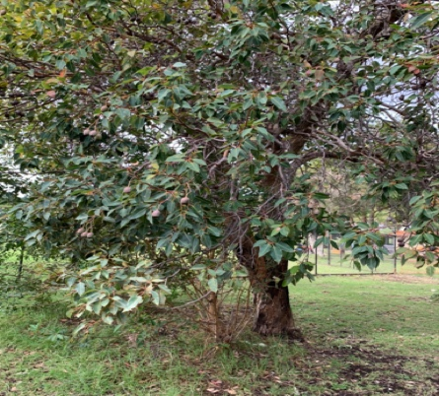
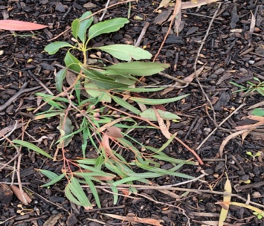

Mind map all of the things that you can both think of that are connected to your question:
Everything, everything that you can think of….
Now.
How about exploring this using Who, What, When, Where, Why and How?
Give each other a job to do… one of you looks at… the other looks at..
Find out some more about the magpie or worms, bees or gumnuts or….

Can you find or download an image of what you are inquiring about?
Fold a sheet of paper into 8 sections.
Draw what you found down the track on this.
Be very careful and look like a scientist as you draw like an artist. Do this together. Give each other feedback on how your drawings are going
Colour your creation with paint or felt tipped pens or crayons and cut it out carefully or perhaps you could make this out of nuts and seeds from the garden?

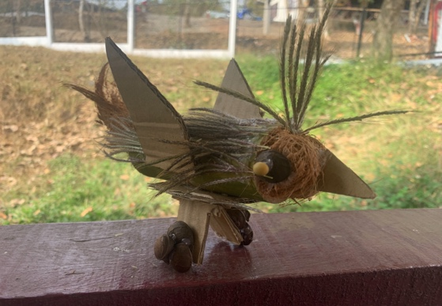
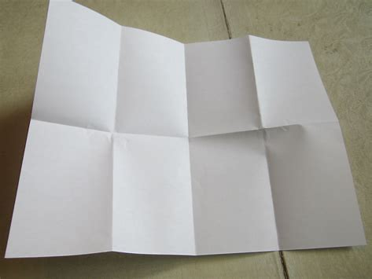

Look through your dilly bag collection of the leaves, twigs, seeds, objects that were at the flag you chose.
Find a cardboard box or some sheets of hard card to create a diorama. Remember your drawing or your creation.
Look at the flag table where you drew what you noticed as you walked the track.
Create a background on the back of the box that looks just like where the flag you stopped at and what you were interested in….. was it bushes, a tree, leaf litter, branches, grass?

Make sure that you create a background just like what you saw outside.
Glue that to the back of your box. Glue your animal, insect, plant that you drew or made into position… into the background scene.
Now put your collection of leaves, nuts, seeds at the front of the box.

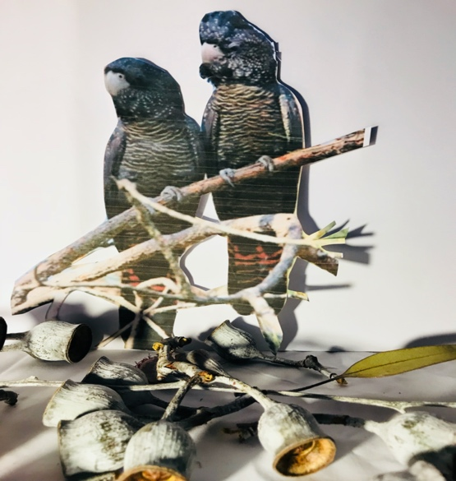
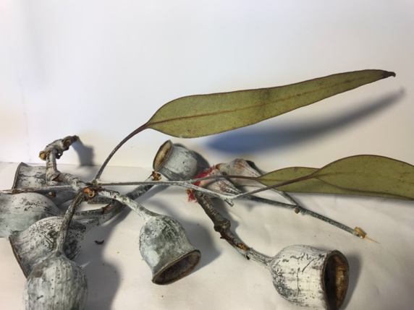

Take a photo of your scene.
Does it look just like what you discovered at the flag you stopped by down the track? Does it?

Now glue your WWWW and H information that you discovered onto the back of the box.
Do you have the answer to what is happening on the school land down the walk track?

Have you captured this? Ask each other how you went?
Did you capture what you were looking at?
Perhaps set up an Exhibition of all of the flag sites that the whole class created in order and line them all up so that you can show what is happening in nature down your school track… here it is…
