What is happening to the Frilled-neck lizard in the desert?
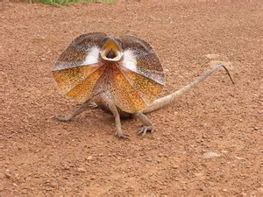
Do you know?

An inquiry based integrated program for Primary school students.

COMMON NAME: Frilled Lizard
SCIENTIFIC NAME: Chlamydosaurus kingii
TYPE: Reptiles
DIET: Carnivores
AVERAGE LIFE SPAN IN THE WILD: Up to 20 years
SIZE: 1 metre
WEIGHT: 500 grams
SIZE RELATIVE TO A 6-FT MAN:

ABOUT THE FRILLED LIZARD Undoubtedly, one of the quirkiest sights in nature is the gangly retreat of an Australian frilled lizard.
Defensive Behavior: When this unique creature feels threatened, it rises on its hind legs, opens its yellow-colored mouth, unfurls the colorful, pleated skin flap that encircles its head, and hisses. If an attacker is unintimidated by these antics, the lizard simply turns tail, mouth and frill open, and bolts, legs splaying left and right. It continues its deliberate run without stopping or looking back until it reaches the safety of a tree. Habitat and Diet: Frilled lizards, or "frillnecks," are members of the dragon family that live in the tropical and warm temperate forests and savanna woodlands of northern Australia. They spend most of their lives in the trees, but descend occasionally to feed on ants and small lizards. Other menu items include spiders, cicadas, termites, and small mammals. Size: They vary in color and size from region to region. On average, the larger adults reach about 1 metre from head to tail and weigh up to 1.1 pounds. Threats to Survival: Their main predators are birds of prey, larger lizards, snakes, dingoes and feral cats. They are currently not threatened or protected, but habitat reduction and predation in some areas, particularly by feral cats, is affecting their populations. Reproduction: Females lay 8 to 23 tiny eggs in an underground nest, and hatchlings emerge fully independent and capable of hunting and utilizing their frill. Their lifespan in the wild is unknown, but specimens in captivity have lived 20 years.
National geographic: www.nationalgeographic.com/animals/reptiles/f/frilled-lizard

Australian Curriculum:
Year 3: Biological sciences: Living things can be grouped together on the basis of observable features and can be distinguished from non-living things
Science involves making predictions and describing patterns and relationships
Year 5: Biological sciences: Living things have structural features and adaptations that help them to survive in their environment
Science involves testing predictions by gathering data and describing patterns and relationships to develop explanations of events and phenomena
Geography: Develop geographical questions to investigate and plan an inquiry.
Literature: How texts reflect the context of culture and situation to describe the effect of ideas, text structures and language features
Personal responses to ideas, characters and viewpoints
Create literacy texts using realistic and fantasy settings and characters.
Literacy: Plan rehearse and deliver oral presentation for defined audiences incorporating accurate and sequenced content.
Connecting ideas to personal experiences: present a personal point of view
Language: Learn extended and technical vocabulary and ways of expressing opinions.
Understand how different types of texts vary in use of language choices, depending on their function and purpose.
Maths : Statistics and probability: Chance: List outcomes of chance experiments involving equally likely outcomes.
Collect data, organize into categories and create displays using tables, graphs.
Visual Arts: Use materials, techniques and processes to explore visual conventions when making art works:
Applying art and design techniques effectively and safely.
Manipulating and experimenting with combinations of various materials
Practicing a variety of techniques and materials to interpret a theme or subject
Cross curriculum priorities: Asia and Australia’s engagement with Asia.
Explore some fiction, non-fiction and traditional texts about Frilled-neck lizards with the students in class for a day or two.

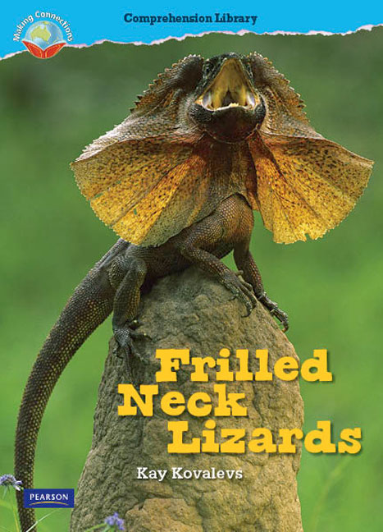
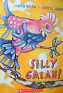
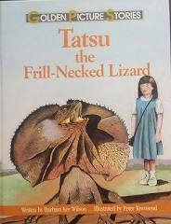
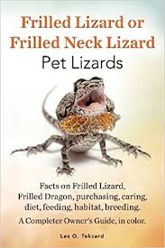
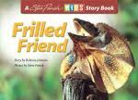

What is happening to the Frilled-neck lizard in the desert?
Do you know?
Introduce inquiry with Inquiry question:

8/10 laminated photos of frilled-neck lizard. Share amongst students. List common features of lizard. What are they? What makes a frilled-neck lizard a frilled-neck lizard?
Graph observable features:

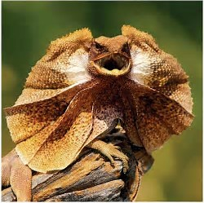

2. Choose a laminated photo of one of the Frilled-neck lizards.
Divide photo into 4/4 squares. Fold large rectangle of calico into 4/4 squares. Transfer image from photo to calico square by square using black pen. Show folds on lizard skin. Think about the skin, trunk, ears feet, frill of the lizard and what adaptions have helped them to survive.

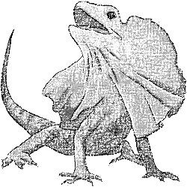

3. Create a border at the bottom of the calico:.....crayon rub or block print sand, stems, leaves, rocks, grasses, branches, termite nests under the lizard’s feet.
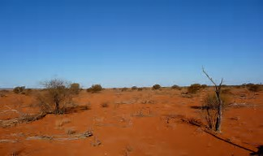

- Mind map: Everything students know about elephants: Then divide into categories:

Mind Map everything connected to Frilled-neck lizard

Mind map of everything connected to Frilled-neck lizard
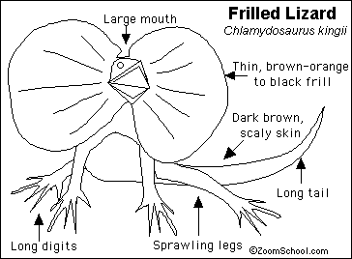

- Sort ideas: Discuss
e.g Geographical features of where lizards live.
Size
Shape
Frill?
Families
Life cycle
What do they eat?
Smell
Touch
Movement
How long do they live?
How accessible is their food to them?
Do they need water? How much?
More?

- Help the students to develop a set of prompt level 4 BLANK questions about the Frilled-neck lizard related to each category.

- Then: Encourage them to think about choosing their own Inquiry question:
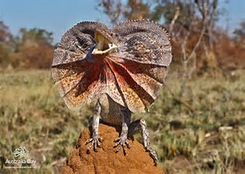
- What could happen if
- Why did
- Why has
- What could
- Why cant
- How could
- What will
- Why are
- What could
- If…….. etc.,

- Students choose the inquiry question that interests them most in relation to the frilled- neck lizard:
Then: How will they find the answers to their inquiry?
Where?
How will they record them?
How will they present them?
How will the group celebrate the work and the answer to the inquiry?

9. Create an inquiry task sheet with each student: Collect two samples of work from each curriculum area:
Literacy: | Language | Literature
Number: | Measurement: | Science:
Geography: | History: | Visual arts

Then: Focusing upon Visual arts:
10: Wash calico background: desert/ sky colours… in keeping with images
11. Use crayon to outline the frilled-neck lizard: Paint. Water down the paint. Make sure the folds are distinguishable and the rough surface of the skin is highlighted with crayon.
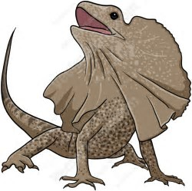

12. Designs on legs with ribbon/sequins/ felt….glueing
13. Block print around the frill
14. Buttons/ sequins on body
15. Eye bead or button for lizard eye with sequins surrounding.

16. Little felt frilled-neck lizards on ribbons to hang from the bottom of the collage to highlight the diminishing numbers:

Equipment needed:
Calico
Cardboard, lids, bottles, tops, boxes, paper scraps, boxes, plastic bottles
Felt tip pens
Pencils, crayons
Black highlight pens
White glue/ masking tape, cellotape
Sequins, pipe cleaners, pegs, buttons, paper towels, cellophane, colored papers, wool etc.,
Needle/ cotton and wool
Collage craft materials:
Pop sticks, scraps of material, card

Large sheets of white paper

Paints /edicol dyes /brushes
Exhibition:

This is what I now know about frilled-neck lizards in the desert in 2017

